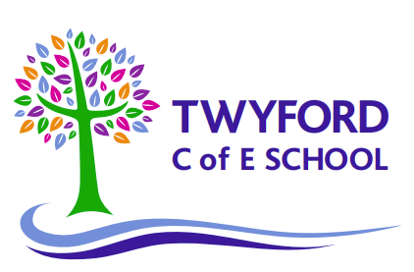
Phonics Screening Check:
A Guide for Parents

What is the phonics screening check?
The phonics screening check is a quick and easy check of your child’s phonics knowledge. The national phonics screening check is taken by all Year 1 pupils in the country. It is a short, statutory assessment to ensure that children are making sufficient progress in the phonics skills needed to read words. It helps the school confirm whether your child has made the expected progress.

The phonics check comprises of a list of 40 words that children read one-to-one with a teacher. The list is a combination of 20 real words and 20 pseudo words (nonsense or non-words) which rely purely on using phonics to decode and read. The pseudo words have been made up and will be shown with a picture of an imaginary creature to help identify them. Mrs Rumble will administer the check and it will take approximately 10 minutes per child. The children will largely be unaware of it being a test and have already participated in several practice ones this year.

Who takes the test and when?
The Phonics Screening Check was introduced by the Government in 2012 for all Year 1 pupils across the country. All Year 1 children will be required to take the test during the week beginning 12th June. Any Year 2 children that did not achieve the expected level last year will also be required to retake the test.

Reporting to parents
All schools must report results of the check to parents. We will also confirm if your child has met the standard threshold. This information will be included in your child’s end of year report. Children who do not achieve the expected level will be required to retake the test in June 2024. Your child’s class teacher will discuss the assessment results with you and any additional support you can give your child if a retake next June is required.

How the results are used
Results from the check will be used to analyse and track our school phonics performance and will be made available for Ofsted to use in future inspections.

How can I help my child to prepare?
- Read as often as possible to and with your child.
- If your child is struggling to decode a word, help them by encouraging them to say each sound in the word from left to right.
- Access the Little Wandle website (link below) to find more information. The 'For Parents' section provides videos of how to pronounce the Phase 2 and Phase 3 sounds and how we teach the reading of words.
- https://www.littlewandlelettersandsounds.org.uk/resources/my-letters-and-sounds/
- Please see the school website with an example of a past phonics screening assessment.

